Artikels – 50%
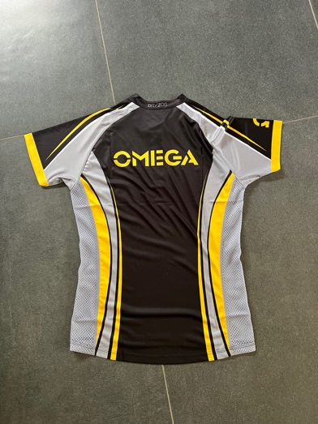
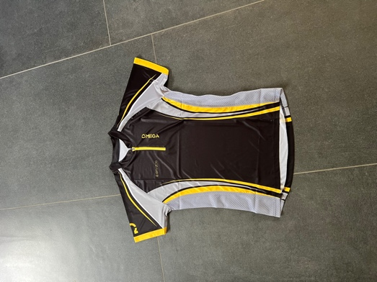
Bryzos OL -shirt model 2017

Unisex: 1L, 2XXXL

Kids: 1x150

Volw: 32,00 – 50% = 16,00€
Kids: 23,00 – 50% = 11,50€

Bryzos OL-kniebroek model 2017
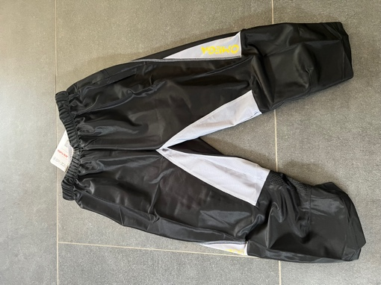
Volw: 4XS, 4S, 1XXL, 1XXXL

Kids: 2x120 , 130, 3x150

Volw: 23,00 – 50% = 11,50€
Kids: 18,00 – 50% = 9,00€

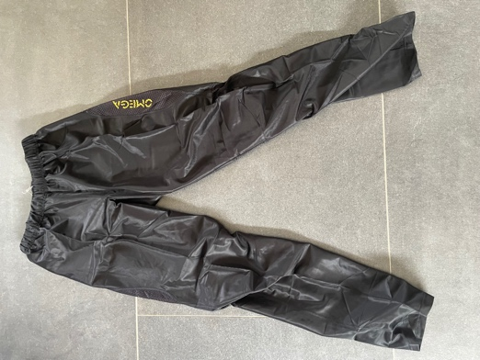
Bryzos OL-broek lang model 2017

Volw: 1S, 1M, 3L, 2XL, 2XXL, 2XXXL

18,00 – 50% = 9,00€

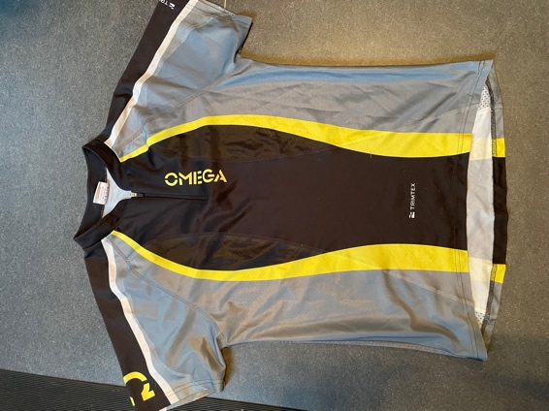
Trimtex extreme OL-shirt model 2007 met rits

8XS

30 – 50% = 15,00€

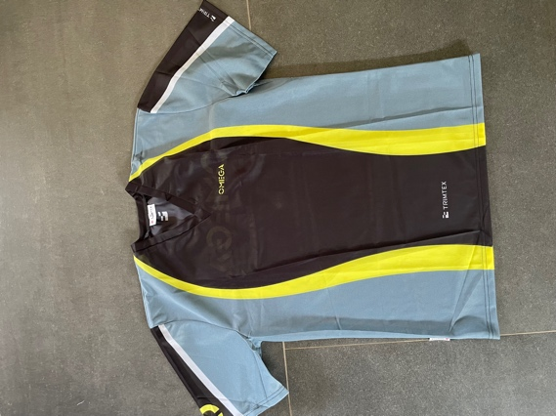
Trimtex klassiek OL-shirt met V-hals, zonder rits

Volw: 1M

30,00 – 50% = 15,00€

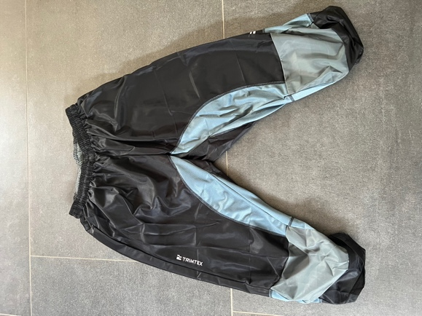
Trimtex OL-kniebroek

Volw: 2XS, 4S

Kids: 1x150

Volw: 21,00 – 50% = 10,50€
Kids: 16,00 – 50% = 8,00€

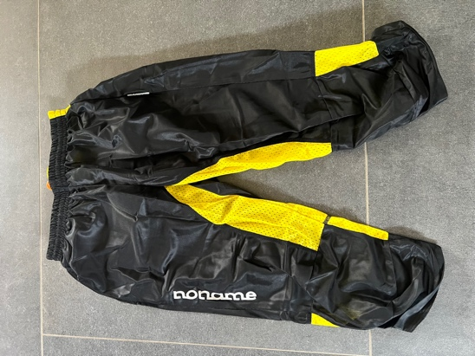
Noname OL-kniebroek zwart-geel

2XS, 3S

21,00 – 50% = 10,50€

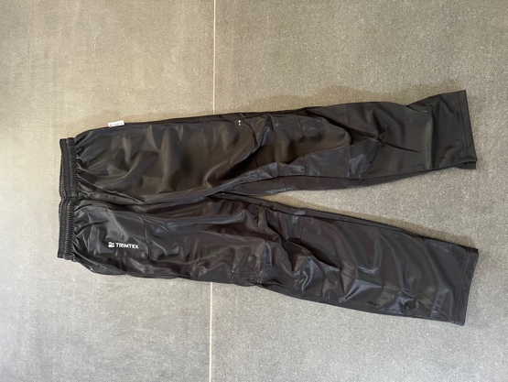
Trimtex OL-broek lang

XXS (kids)

13,00 – 50% = 6,50€

Sportvögl OL-broek lang

Kids: 2x160

10, 00 – 50% = 5,00€

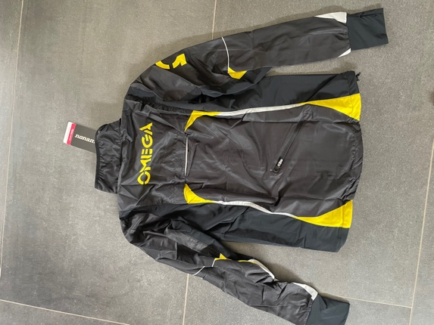
Noname Trainingsvest
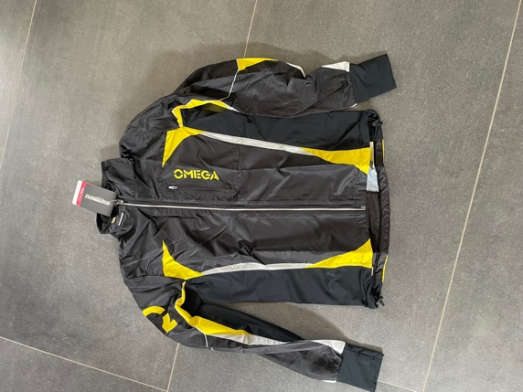
Volw: 5M

Kids: 1x130, 7x150

Volw: 72,00 – 50% = 36,00€
Kids: 62,00 – 50% = 31,00€

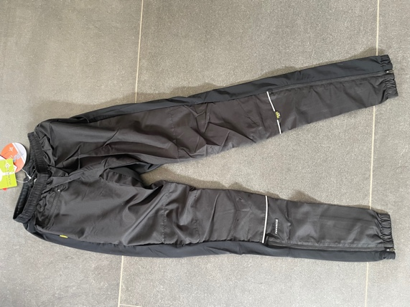
Noname Trainingsbroek

Kids: 1x150, 1XXS

36,00 – 50% = 18,00€

Overige artikels

Kalenji T-shirt lange mouwen zwart
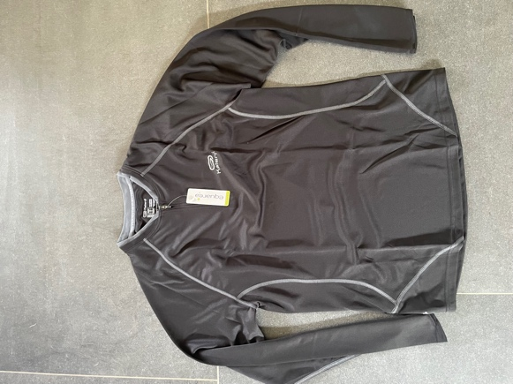
1M, 1L

12,00€

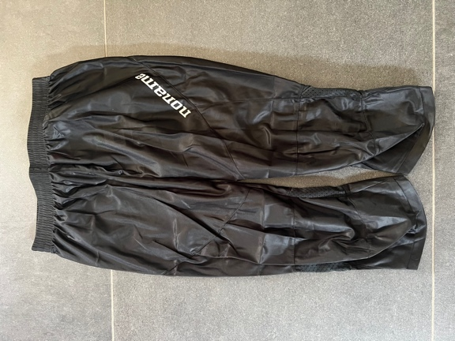
Noname OL-kniebroek zwart

1M, 2L

21,00€

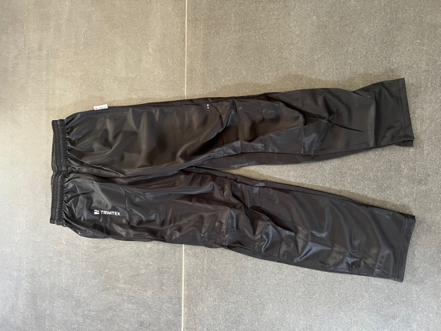
Noname OL broek lang

2L, 2XXL

18,00€

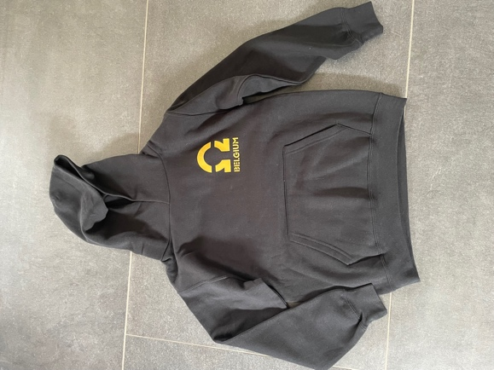
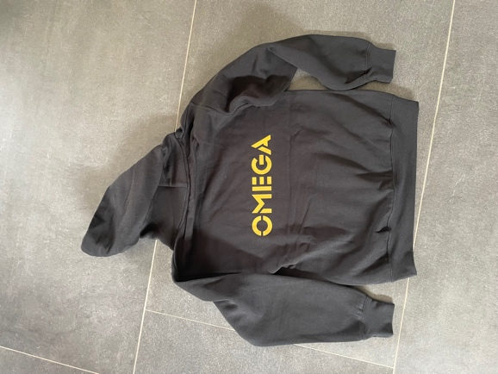
Hoodie

Men: 14S, 2M, 1L

Women: 11S, 1M, 1L

Kids: 18x152

Volw: 27,50€
Kids: 21,50€

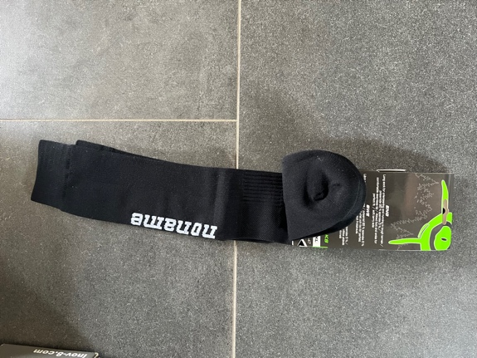
Noname OL-kousen zwart

2XL

15,00€

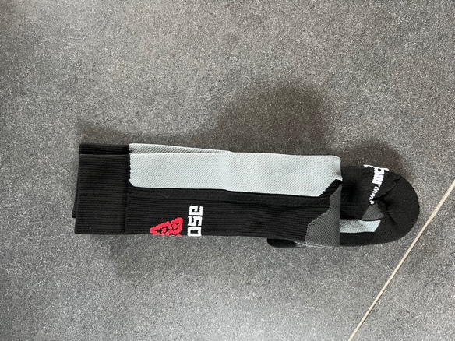
Moose OL-kousen

4XS, 2S

15,00€

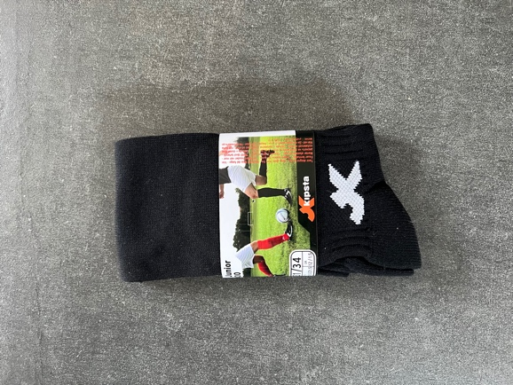
Kipsta OL-kousen

Kids: 1x 35-38

4,50€

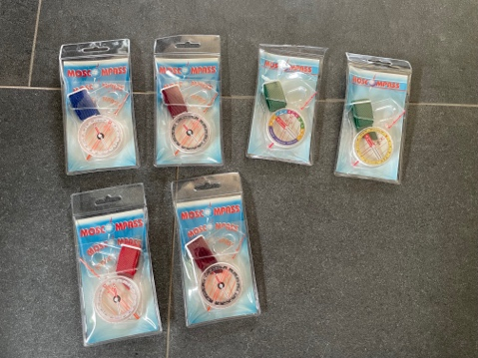
Moskow duimkompas

Model 2: 32,00€
Model 3: 32,00€
Model 8: 28,00€
Model 11: 22,00€

Baliesje auto: 3,25€
Postenbeschrijvinghouder oranje: 5,25€
Postenbeschrijvinghouder VAPRO L: 9,00€
Postenbeschrijvinghouder VAPRO S: 8,00€
Sportident SI card 9: 34,00€
Sportident SI card 10: 44,00€
Sportident SI card AIR: 57,00€

